Experiment -2
Property Buying & Rental System Using Zoho One (SaaS)
Aim
To develop a Property Buying and Rental System using Zoho One (SaaS) to manage property details, customer information, property purchases, rental agreements, tenant details, and payment records efficiently through cloud-based applications.
Procedure
- Log in to the Zoho One cloud platform.
- Open Zoho Creator from the Zoho One applications.
- Create a new application named Property Buying & Rental System.
- Create a new form named Property Details. Add the required field
- Configure the field types according to the data required.
- Add Buy and Rent options under Transaction Type.
- Add Residential, Commercial, Apartment, Villa, Independent House, and Plot under Property Type.
- Add Chennai locations such as Chennai, Tambaram, Porur, Avadi, Poonamallee, Sriperumbudur, OMR, Velachery, and Guindy.
- Add the Property Value and Rental Value fields to store the corresponding property costs.
- Add the Rental Agreement field with Yes/No options.
- Add the Property Status field with options such as Available, Booked, Sold, and Rented.
- Design and arrange the form for easy user interaction.
- Save and publish the form.
- Enter sample property details into the form.
- Submit the form and verify that the entered data is stored in the cloud.
- Open the report and verify the submitted property record.
- Test the application by entering different buying and rental property details.
- Verify that the Property Buying & Rental System works successfully as a SaaS application.

Input:
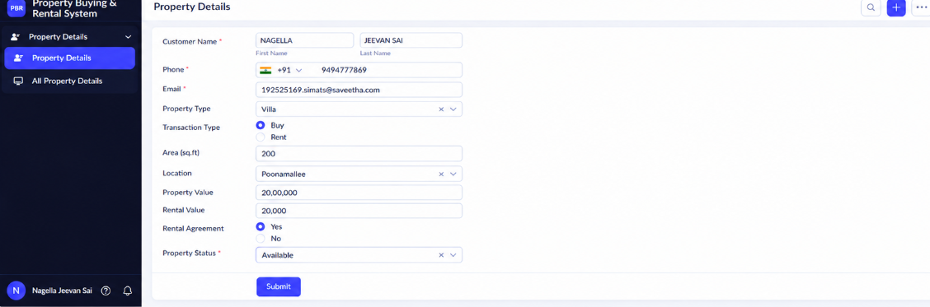

Output:
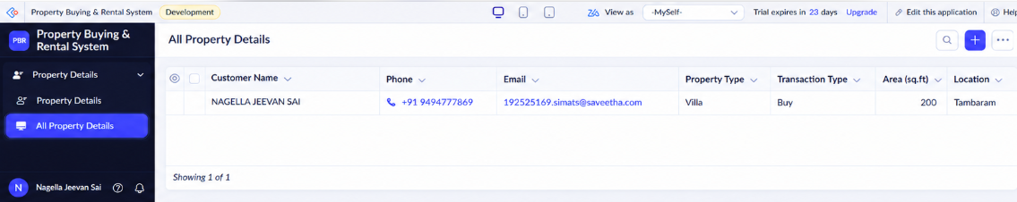

Result
Thus, a Property Buying & Rental System was successfully created using Zoho One and demonstrated as a Software as a Service (SaaS) application.

